GRADE 7 ACCELERATED · UNIT 2 · LESSON 1
Square Values
Worksheet 7A.02.01 ANSWER KEY

1. Complete the table. Each area is the side length multiplied by itself.
Side s | 1 | 2 | 3 | 4 | 5 | 6 | 7 | 8 | 9 | 10
Area s² | 1 | 4 | 9 | 16 | 25 | 36 | 49 | 64 | 81 | 100

These ten values are the perfect squares students should recognize on sight. A student who writes 20 under s = 10 has multiplied by 2 instead of squaring — the single most common error on this benchmark.
2. Select ALL of the numbers below that are perfect squares.
☒ | 1 | ☐ | 8
☒ | 16 | ☐ | 20
☒ | 36 | ☐ | 45
☒ | 49 | ☐ | 60
☒ | 64 | ☒ | 100

Six of the ten. 8, 20, 45 and 60 are the distractors: each is close to a perfect square but is not one. Ask for the whole number that was squared — a student who cannot name it has not shown the answer.
For questions 3 through 5, find the area of a square with the side length given.
3. Side length 12 units
Area = 12² = 12 × 12 = 144 square units
4. Side length  cm
Area =  × = 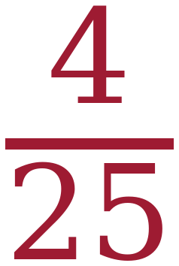 cm²
Square the numerator and square the denominator. The answer is not 4/5.
5. Side length 0.7 units
Area = 0.7 × 0.7 = 0.49 square units
Two decimal places in, two out. A student who answers 4.9 has multiplied by 7 rather than 0.7.
For questions 6 through 8, find the length of one side of a square with the area given.
6. Area 81 square inches
9 × 9 = 81, so the side is 9 inches.
7. Area 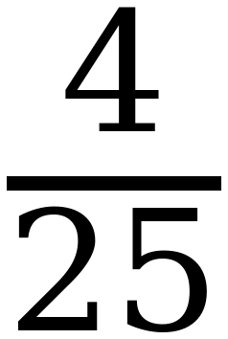 square centimeters
2 × 2 = 4 and 5 × 5 = 25, so the side is cm.
8. Area 2.25 square units
1.5 × 1.5 = 2.25, so the side is 1.5 units.
A side length is a distance, so only the positive value is used here. The negative one, −1.5, arrives in Lesson 2, where the question becomes x² = 2.25 instead of “what is the side?”
Questions 9 and 10 use the equation y = x².
9. Complete the table of values. Then plot the seven points on the grid.
x | Substitute into y = x² | Coordinates (x, y)
−3 | y = (−3)² = 9 | (−3, 9)
−2 | y = (−2)² = 4 | (−2, 4)
−1 | y = (−1)² = 1 | (−1, 1)
0 | y = (0)² = 0 | (0, 0)
1 | y = (1)² = 1 | (1, 1)
2 | y = (2)² = 4 | (2, 4)
3 | y = (3)² = 9 | (3, 9)

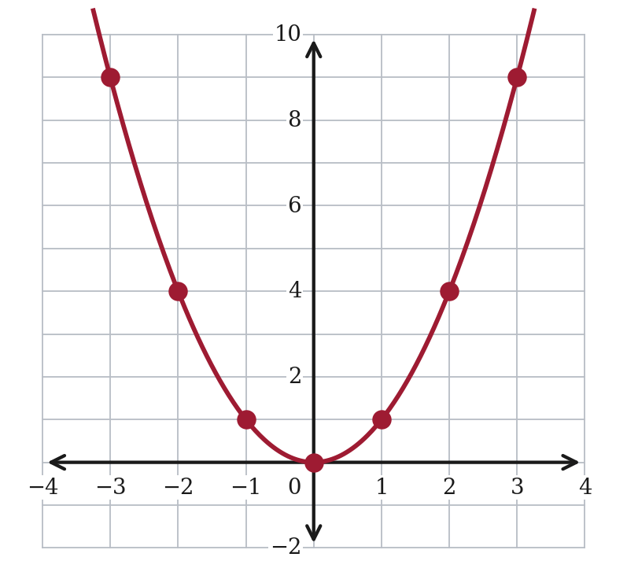
Opposite x-values give the same y-value, which is the whole reason the graph is symmetric.
10. Will the graph of y = x² ever go below the x-axis? Explain why or why not.
No. A positive number times itself is positive, and a negative number times itself is also positive.
The only value of x that gives y = 0 is x = 0, so the graph touches the x-axis at (0, 0) and is above it everywhere else.
The point requires both halves: why y is never negative, AND what happens at x = 0. A student who writes “the graph is always positive” has missed the origin.
11. Can a square have an area of 8 square units? If it can, name the two whole numbers its side length falls between. Explain how you know.
Yes. The side is between 2 and 3.
2 × 2 = 4, which is too small, and 3 × 3 = 9, which is too big. So the side length is bigger than 2 and smaller than 3.
The side is not a whole number.
Do not accept “the side is a decimal or a fraction.” It is neither — but that is Lesson 4's work, and students are not expected to say so yet. The point needs 2 and 3 identified and the two products given as the reason.

